Lecture 9.
Hepatitis viruses. The causative agents of latent viral infections. Human immunodeficiency viruses (HIV). Oncogenic viruses. Prion infections
The purpose of the lecture: To inform students about the characteristics of hepatitis viruses and human immunodeficiency virus, the pathogenesis of the diseases they cause, the main clinical signs, the principles of microbiological diagnosis, treatment and prevention, as well as modern ideas about oncogenic viruses and viral oncogenesis. Provide information on prion infections.
Note. In this lecture, the teacher should try to explain the importance of the characteristics of these viruses in the pathogenesis, microbiological diagnosis, treatment and prevention of the diseases they cause.
Lecture plan:
1. Hepatitis viruses, classification
- Hepatitis A virus. Characteristics of the virion. Resistance, ways of infection, pathogenesis. Microbiological diagnostics. Specific prevention.
- Hepatitis B virus. Virion structure, antigens, persistence, ways of infection. Pathogenesis of the disease. Immunity. Microbiological diagnostics. Specific prevention.
- Hepatitis D virus. Structure of the virion, pathogenetic features of the disease
- Hepatitis C virus, characteristics, genotypes, ways of infection, pathogenesis. Microbiological diagnostics. Specific prevention problem.
- Hepatitis E virus. Virion structural features, genome, antigens, cultivation, persistence, ways of infection. Pathogenesis, clinic, complications of the disease (during pregnancy). Microbiological diagnosis, specific prevention
- Hepatitis G virus. Virion structural features, epidemiology, role in human pathology. Microbiological diagnostics.
2. Retroviruses. Human immunodeficiency viruses, classification. Virion structure, structural and non-structural genes. Continuity, ways of infection. Pathogenesis. Opportunistic infections. Microbiological diagnosis of HIV infection. Prevention problem and treatment preparations.
3. Oncogenic viruses. Historical development of the concept of the role of viruses in the etiology of malignant tumors. Modern theories of carcinogenesis. Mechanism of viral oncogenesis. Classification of oncogenic viruses.
4. Oncogenic viruses that cause tumors in humans:
- DNA-containing oncogenic viruses:
- Herpesviridae family: cytomegalovirus, Epstein-Barr virus, human herpes virus type 8.
- Hepadnaviridae family - hepatitis B virus
- Papillomaviridae family, general characteristics, types, pathogenetic characteristics of diseases caused by it, specific prevention.
- Poliomaviridae family. Merkel polyomavirus.
- RNA-containing oncogenic viruses:
- Retroviridae family: human T-lymphotropic viruses (Human T-lymphotropic virus, HTLV
- Family Flaviviridae Genus Hepacivirus – hepatitis C virus.
5. Prion infections.
HEPATITIS VIRUSES
Trigger Words
Hepatitis A: acute/sudden onset, picornavirus, fecal-oral
Hepatitis B: blood-borne, STD, hepadnavirus, reverse transcriptase, chronic, Dane particle, HBsAg
Hepatitis C: chronic, blood-borne, flavivirus
Hepatitis D: defective, hepatitis B helper virus, fulminant disease
Hepatitis E: fecal-oral, acute/sudden onset, pregnant women

Biology, Virulence, and Disease
ᑏᑏ Liver disease defines symptoms
ᑏᑏNonlytic viruses: cell-mediated immunity causes symptoms
ᑏᑏHepatitis A: nonlytic picornavirus, acute onset, no sequelae
ᑏᑏHepatitis B: hepadnavirus, enveloped and encodes reverse transcriptase
ᑏᑏDisease followed by serology
ᑏᑏChronic disease 5% of time, especially in children
ᑏᑏ Risk for PHC
ᑏᑏHepatitis C: flavivirus
ᑏᑏCauses chronic disease in 70% of patients
ᑏᑏ Risk for PHC and cirrhosis after long period
ᑏᑏHepatitis D: viroid-like, requires HBV as helper virus
ᑏᑏHepatitis E: Hepevirus, calici-like virus, acute onset, no sequelae, severe for pregnant women

Epidemiology
ᑏᑏHAV, HEV: fecal-oral transmission
ᑏᑏHBV, HCV, HDV: spread in blood, tissue, and semen; STDs

Diagnosis
ᑏᑏ RT-PCR, ELISA

Treatment, Prevention, and Control
ᑏᑏHAV: inactivated vaccine, hygiene
ᑏᑏHEV: hygiene
ᑏᑏHBV: virus-like particle HBsAg vaccine, screening of blood supply, safe sex, antiviral drugs
ᑏᑏHCV: screening of blood supply, safe sex, antiviral drugs
ᑏᑏHDV: immunization for HBV
ELISA, Enzyme-linked immunosorbent assay; HAV, hepatitis A virus; HBsAg, hepatitis B surface antigen; HBV, hepatitis B virus; HCV, hepatitis C virus; HDV, hepatitis D virus; HEV, hepatitis E virus; PHC, primary hepatocellular carcinoma; RT-PCR, reverse transcriptase-polymer chain reaction; STD, sexually transmitted disease.

Comparative Features of Hepatitis Viruses
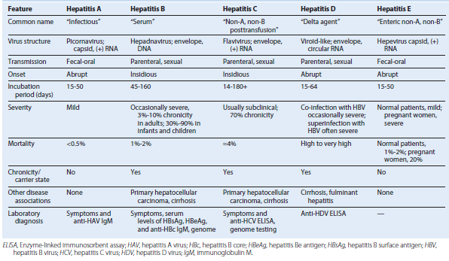

Characteristics of Hepatitis A Virus

Stable to:
Acid at pH 1
Solvents (ether, chloroform)
Detergents
Salt water, groundwater (months)
Drying (stable)

Temperature:
4° C for weeks: stable
56° C for 30 minutes: stable
61° C for 20 minutes: partial inactivation

Inactivated by:
Chlorine treatment of drinking water
Formalin (0.35%, 37° C, 72 hours)
Peracetic acid (2%, 4 hours)
β-Propiolactone (0.25%, 1 hour)
Ultraviolet radiation (2 μW/cm2/min)

Picornavirus structure of hepatitis A virus. The icosahedral capsid is made up of four viral polypeptides (VP1 to VP4). Inside the capsid is a single-stranded positive-sense ribonucleic acid (ssRNA) that has a genomic viral protein (VPg) on the 5′ end.

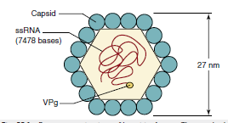

Spread of hepatitis A virus within the body.
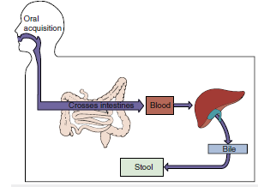

Epidemiology of Hepatitis A Virus and Hepatitis E Virus
Disease/Viral Factors
Capsid viruses are strongly resistant to inactivation.
Contagious period extends from before to after symptoms.
Virus may cause asymptomatic shedding.
Transmission
Virus can be transmitted via fecal-oral route.
Ingestion of contaminated food and water can cause infection.
HAV in shellfish is from sewage-contaminated water.
HEV from pigs and game animals.
Virus can be transmitted by food handlers, day-care workers, and children.
Who Is at Risk?
People in overcrowded, unsanitary areas
Travelers to high-risk regions
Children: mild disease, possibly asymptomatic; day-care centers are a major source of spread of HAV
Adults: abrupt-onset hepatitis
Pregnant women: high mortality associated with HEV
Geography/Season
Virus is found worldwide.
There is no seasonal incidence.
Means of Control
Good hygiene.
HAV: passive antibody protection for contacts
Killed vaccine
Live vaccine in China

Unique Features of Hepadnaviruses
Virus has enveloped virion containing partially double-stranded, circular DNA genome.
Replication is through an overlapping circular RNA intermediate.
Virus encodes and carries a reverse transcriptase.
Virus encodes several proteins (HBsAg [L, M, S]; HBe/HBc antigens) that share genetic sequences but with different in-frame start codons.
HBV has a strict tissue tropism to the liver.
HBV-infected cells produce and release large amounts of HBsAg particles lacking DNA.
The HBV genome can integrate into the host chromosome.
HBc, Hepatitis B core antigen; HBe, hepatitis Be antigen; HBsAg, hepatitis B surface antigen; HBV, hepatitis B virus.

Hepatitis B virus (Dane particle) and hepatitis B surface antigen (HBsAg) particles. The spherical HBsAg consists mainly of the S form of HBsAg, with some M. The filamentous HBsAg has S, M, and L forms. bp, Base pair; DNA, deoxyribonucleic acid; L, gp42; M, gp36; S, gp27.
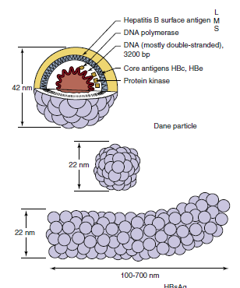

Replication of hepatitis B virus (HBV). After entry into the hepatocyte and uncoating of the nucleocapsid core, the partially double-stranded deoxyribonucleic acid (DNA) genome is delivered to the nucleus and completed. Transcription of the genome produces four messenger RNAs (mRNAs), including an mRNA larger than the genome (3500 bases). The mRNA then moves to the cytoplasm and is translated into protein. Core proteins assemble around the 3500-base mRNA, and negative-sense DNA is synthesized by a reverse transcriptase activity in the core. The ribonucleic acid (RNA) is then degraded while a positive sense (+) DNA is synthesized. The filled core associates with HBsAg containing endoplasmic reticulum membranes, is enveloped before completion of the positive-sense DNA, and is then released by exocytosis with HBsAg-containing particles. HBeAg, Hepatitis Be antigen; HBsAg, hepatitis B surface antigen.
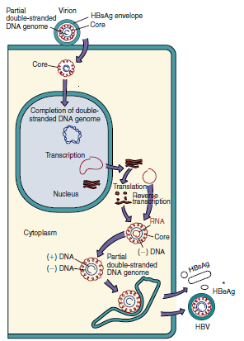

DNA, RNA, messenger RNA (mRNA), and proteins of hepatitis B virus. The inner green circles represent the DNA genome, with the nucleotide number at the center. DR1 and DR2 are direct repeat sequences of DNA and are important for replication and integration of the genome. The 3500-base transcript (outer black thin-line circle) is larger than the genome and is the template for replication of the genome. Bold arcs represent mRNA for viral proteins. Note that several proteins are translated from the same mRNA but from different AUG codons and that different mRNAs overlap. AAA, 3′ PolyA (polyadenylate) at end of mRNA; AUG, adenine, uracil, guanine; C, C mRNA for hepatitis B core antigen (HBcAg); HBsAg, hepatitis B surface antigen; l, large glycoprotein; m, medium glycoprotein; P, polymerase; s, small glycoprotein; S, mRNA for HBs antigen; X, X mRNA. (From Cohen, J., Powderly, W.G., Opal, S.M., 2010. Infectious Diseases, third ed. Mosby, Philadelphia, PA.)

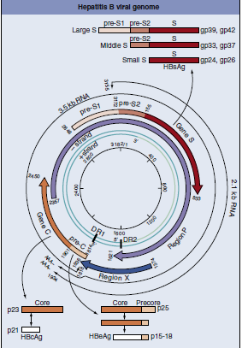

Major determinants of acute and chronic hepatitis B virus (HBV) infection. HBV infects the liver but does not cause direct cytopathology. Cell-mediated immune lysis of infected cells produces the symptoms and resolves the infection. Insufficient immunity can lead to chronic disease. Chronic HBV disease predisposes a person to more serious outcomes. Purple arrows indicate symptoms; green arrows indicate a possible outcome.
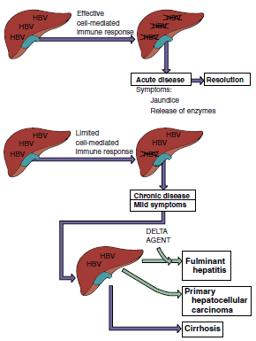

Spread of hepatitis B virus (HBV) in the body. Initial infection with HBV occurs through injection, unprotected sex, and birth. The virus then spreads to the liver, replicates, induces a viremia, and is transmitted in various body secretions in addition to blood to start the cycle again. Symptoms are caused by cell-mediated immunity (CMI) and immune complexes between antibody and hepatitis B surface antigen (HBsAg). IV, Intravenous.

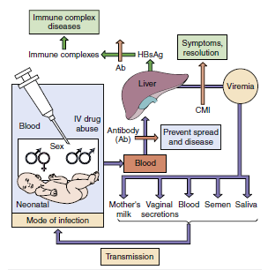

High-Risk Groups for Hepatitis B Virus Infection
People from endemic regions (i.e., China, parts of Africa, Alaska, Pacific Islands)
Babies of mothers with chronic hepatitis B virus
Intravenous drug abusers
People with multiple sex partners
Health care personnel who have contact with blood
Residents and staff members of institutions for the mentally retarded
Hemophiliacs and other patients requiring blood and blood product treatmentsa
Hemodialysis patients and blood and organ recipientsa
a Screening of blood, blood products, and transplantable organs have minimized risk.

Symptoms of typical acute viral hepatitis B infection are correlated with the four clinical periods of this disease. RUQ, Right upper quadrant. (Modified from Hoofnagle, J.H., 1983. Type A and type B hepatitis. Laboratory Medicine 14, 705–716.)

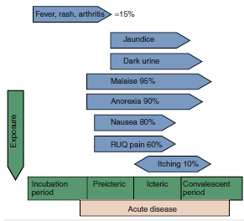

Clinical outcomes of acute hepatitis B infection. HBsAg, Hepatitis B surface antigen. (Modified from White, D.O., Fenner, F., 1986. Medical Virology, third ed. Academic, New York.)
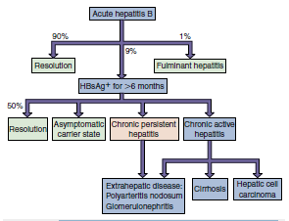

(A) Serologic events associated with the typical course of acute hepatitis B disease. (B) Development of the chronic hepatitis B virus carrier state. Routine serodiagnosis depends on detection of immunoglobulin M anti-HBc during the “hepatitis B surface antigen (HBsAg) window,” when HBs and anti-HBs are undetectable. Anti-HBc, Antibody to hepatitis B core antigen [HBcAg]; Anti-HBe, antibody to hepatitis Be antigen [HBeAg]; Anti-HBs, antibody to HBsAg. (Modified from Hoofnagle, J.H., 1981. Serologic markers of hepatitis B virus infection. Annual Review of Medicine 32, 1–11.)
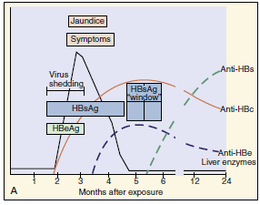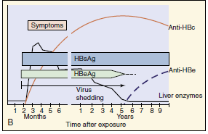

Interpretation of Serologic Markers of Hepatitis B Virus Infection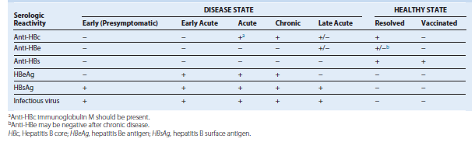

Outcomes of hepatitis C virus infection. Enzymes in green are targets for antiviral drugs.
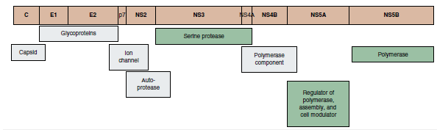

Epidemiology of Hepatitis B, C,and D Viruses
Disease/Viral Factors
Enveloped virus is labile to drying. HBV is less sensitive to detergents than other enveloped viruses.
Virus is shed during asymptomatic periods.
HBV (10%) and HCV (70%) cause chronic infection with potential virus shedding.
Transmission
In blood, semen, and vaginal secretions (HBV: saliva and mother’s milk)
Via transfusion, needlestick injury, shared drug paraphernalia, sexual intercourse, and breast-feeding.
Who Is at Risk?
Children: mild asymptomatic disease with establishment of chronic infection.
Adults: insidious onset of hepatitis.
HBV-infected people co-infected or superinfected with HDV: abrupt, more severe symptoms with possible fulminant disease.
Adults with chronic HBV or HCV: at high risk for cirrhosis and primary hepatocellular carcinoma.
Geography/Season
Viruses are found worldwide.
There is no seasonal incidence.
Modes of Control
Avoidance of high-risk behavior.
HBV: virus-like particle (HBsAg) vaccines.
HBV and HCV screening of blood supply.
HBV, Hepatitis B virus; HCV, hepatitis C virus; HDV, hepatitis D virus.

Hepatitis C proteins and their function. Highlighted proteins are targets for antiviral drugs.
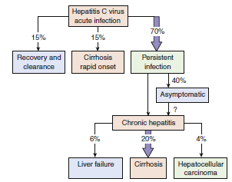

Hepatitis C Antiviral Drugs and Combinations
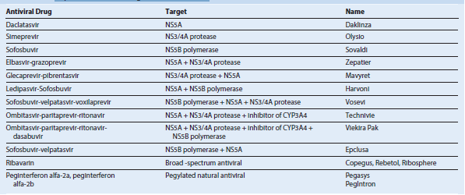

Consequences of delta virus infection. Delta virus (δ) requires the presence of hepatitis B virus (HBV) infection. Superinfection of a person already infected with HBV (carrier) causes more rapid, severe progression than co-infection (shorter arrow).
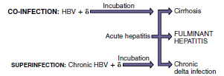

Delta hepatitis virion. HBsAg, Hepatitis B surface antigen; ssRNA, single-stranded RNA.
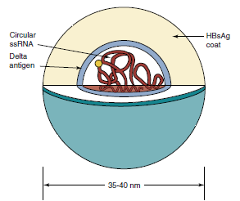

Clinical Summaries
Hepatitis A: A 37-year-old man develops fever, chills, headache, and fatigue 4 weeks after eating at a greasy-spoon diner. Within 2 days, he develops anorexia, vomiting, and right upper quadrant abdominal pain followed by jaundice, dark-colored urine, and pale stools persisting for 12 days. Then symptoms decrease.
Hepatitis B: A 27-year-old IV drug user develops symptoms of hepatitis 60 days after using a dirty needle.
Hepatitis B and D: A different IV drug user develops symptoms of hepatitis, altered mental capacity, and massive hepatic necrosis and then dies.
Hepatitis C: Elevated liver enzymes were detected in an individual during a physical examination. Hepatitis C virus in the blood was detected by enzyme-linked immunosorbent assay. Ten years later, cirrhosis and liver failure developed, requiring a liver transplant.

RETROVIRUSES
Trigger Words - Reverse transcriptase, integration, syncytia
HIV: AIDS, CD4, chemokine co-receptor, opportunistic diseases
HTLV: leukemia, flower cell, CD4 T cell
Biology, Virulence, and Disease
ᑏ Virion: medium size, envelope, nucleocapsid, two copies of (+) RNA genome
ᑏᑏ Simple retroviruses have three genes: gag, pol, env
ᑏᑏComplex retroviruses (HIV, HTLV) have gag, pol, env, and other important genes
ᑏᑏ Encodes RNA-dependent DNA polymerase (RT), replicates in nucleus
ᑏᑏVirion carries RT, integrase, and protease enzymes
ᑏᑏ Replicates through DNA intermediate, integrates viral DNA into host chromosome
ᑏᑏCauses syncytia
ᑏᑏ Incapacitates and escapes immune control
ᑏᑏOncornaviruses may encode oncogene and have a short latency period before cancer
ᑏᑏHTLV-1, no oncogene, long latency period before leukemia
ᑏᑏHTLV: acute T-cell lymphocytic leukemia, tropical spastic paraparesis
ᑏᑏHIV: initially infects CD4/CCR5 macrophages, dendritic cells, and T cells; initial disease phase resembles mononucleosis followed by latent period; AIDS results when CD4 T cells drop below 200/μL
ᑏᑏ Endogenous retroviruses: integrated and approximately 8% of human genome
Epidemiology
ᑏᑏWorldwide
ᑏᑏ Transmitted in blood and semen
ᑏᑏHigh-risk groups: promiscuous individuals, IV drug users, infants of infected mothers
Diagnosis
ᑏᑏ RT-PCR, ELISA
Treatment, Prevention, and Control
ᑏᑏHIV treatment with nucleoside analogs, protease inhibitors, and other antiviral drugs
ᑏᑏ Prevention by screening of blood supply, safe sex, antiviral drug prophylaxis, education
Classification of Retroviruses
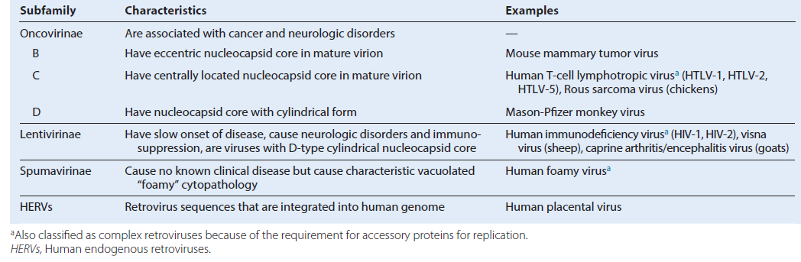

Morphologic distinction of retrovirions. The morphology and position of the nucleocapsid core are used to classify the viruses. A-type particles are immature intracytoplasmic forms that bud through the plasma membrane and mature into B-type, C-type, and D-type particles.
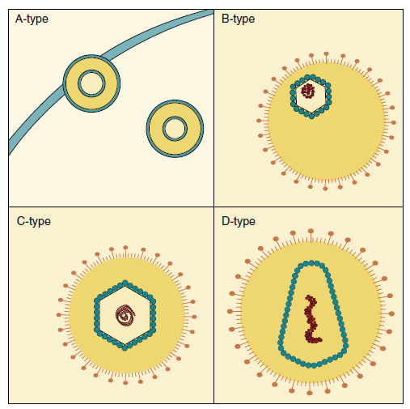
Unique Characteristics of Retroviruses
Virus has an enveloped spherical virion that is 80 to 120 nm in diameter and encloses a capsid containing two copies of the positive-strand RNA genome (≈9 kilobases for HIV and human T-cell lymphotropic virus).
RNA-dependent DNA polymerase (reverse transcriptase), two copies of tRNA, protease, and integrase enzymes are carried in the virion.
Virus receptor is the initial determinant of tissue tropism.
Replication proceeds through a DNA intermediate termed the provirus.
The provirus integrates randomly into the host chromosome and becomes a cellular gene.
Transcription of the genome is regulated by the interaction of host transcription factors with promoter and enhancer elements in the long terminal repeat portion of the genome.
Simple retroviruses encode gag, pol, and env genes.
Complex viruses also encode accessory genes (e.g., tat, rev, nef, vif, and vpu for HIV). Virus assembles and buds from the plasma membrane. Final morphogenesis of HIV requires protease cleavage of Gag and Gag-Pol polypeptides after envelopment.
Cross section of HIV. The enveloped virion contains two identical ribonucleic acid (RNA) strands, RNA polymerase, integrase, and two transfer RNAs (tRNA) base-paired to the genome within the protein core. This is surrounded by proteins and a lipid bilayer. The envelope spikes are the glycoprotein (gp)120 attachment protein and gp41 fusion protein. CA, Capsid; MA, matrix; NC, nucleocapsid; SU, surface component; TM, transmembrane component of envelope glycoprotein.
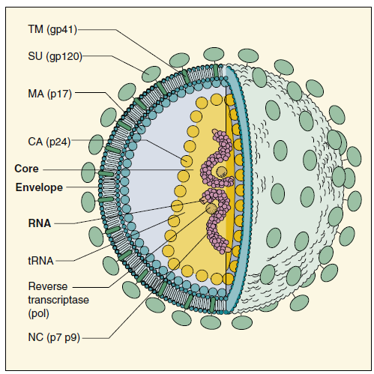
Retrovirus Genes and Their Function
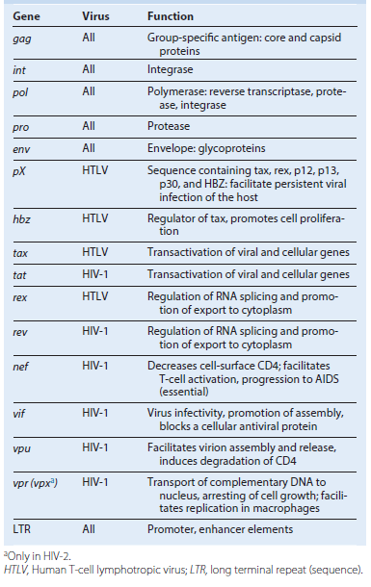

Life cycle of HIV. HIV binds to CD4 and chemokine coreceptors and enters by fusion. The genome is reverse transcribed into deoxyribonucleic acid (DNA) in the cytoplasm, enters the nucleus, and is integrated into the nuclear DNA. Transcription and translation of the genome occur as a cellular gene in a fashion similar to that of human T-cell lymphotropic virus. The virus assembles at the plasma membrane and matures after budding from the cell. cDNA, Complementary DNA; mRNA, messenger ribonucleic acid.
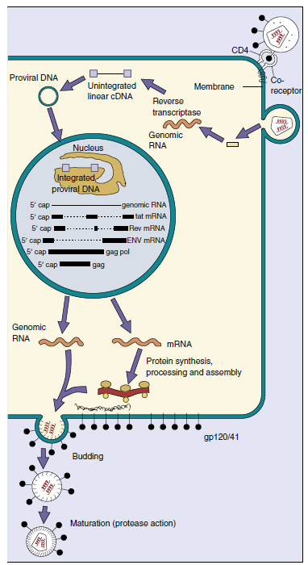
Target cell binding of human immunodeficiency virus (HIV). The CCR5 chemokine receptor is a co-receptor with CD4 on initial infection of an individual, and after mutation of the env gene, the CXCR4 receptor is also used. RNA, Ribonucleic acid.
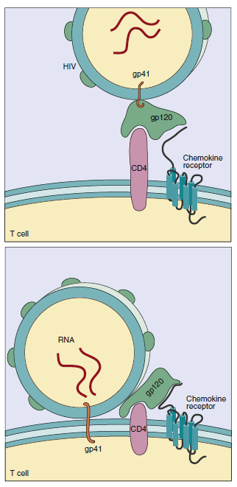

Pathogenesis of human immunodeficiency virus (HIV). HIV causes lytic and latent infection of macrophage, dendritic cells, and CD4 T cells and disrupts neuronal function. The outcomes of these actions are immunodeficiency and acquired immunodeficiency syndrome (AIDS) dementia. CNS, Central nervous system. 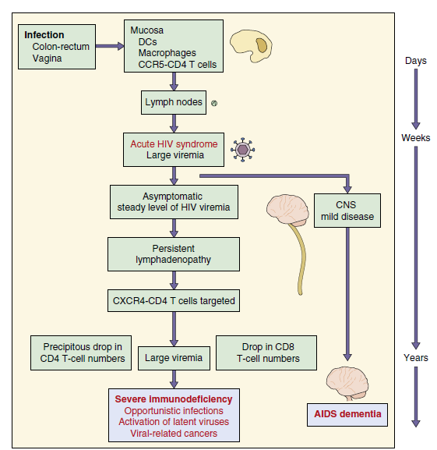

Disease Mechanisms of Human Immunodeficiency Virus
HIV primarily infects CD4 T cells and cells of the myeloid lineage (e.g., monocytes, macrophages, alveolar macrophages of the lung, dendritic cells, and microglial cells of the brain).
Virus mutates during chronic infection and switches from myeloid/T-cell tropic to T-cell tropic based on co-receptor preference.
Virus causes lytic infection of activated permissive CD4 T cells and induces apoptosis-like death of nonpermissive CD4 T cells.
Virus causes persistent low-level productive and latent infection of myeloid lineage cells and memory T cells.
Virus causes syncytia formation, with cells expressing large amounts of CD4 antigen (T cells); subsequent lysis of the cells occurs.
Virus alters T-cell, dendritic cell, and macrophage cell function.
Virus reduces CD4 T-cell numbers and helper-cell activation of CD8 T-cell, macrophage, and other cell functions.
CD8 T-cell numbers and macrophage function decrease.
Infected microglial cells disrupt neuronal function.

Time course and stages of human immunodeficiency virus (HIV). A long clinical latency period follows the initial mononucleosislike symptoms. Initial infection is with the R5–M-tropic virus, and following mutation, the X4–T-tropic virus. The progressive decrease in the number of CD4 T cells, even during the latency period, allows opportunistic infections to occur. The stages in HIV disease are defined by the CD4 T-cell levels and occurrence of opportunistic diseases. HIV can be detected by the presence of p24, HIV genome, or antibodies to the virus.
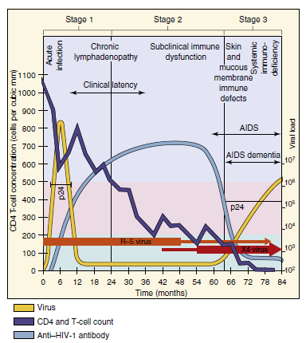

CD4 T cells have a critical role in activating and regulating cell-mediated immune responses, especially toward intracellular pathogens. Human immunodeficiency virus (HIV)–induced loss of CD4 T cells results in loss of the functions activated and regulated by the indicated cytokines. IFN, Interferon; IL, interleukin; NK, natural killer; TGF-_, transforming growth factor-β.
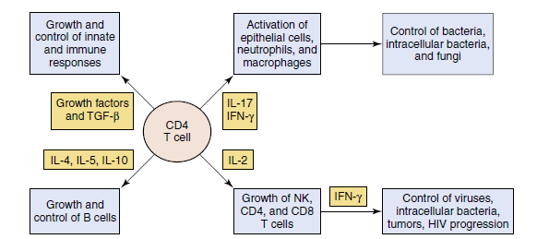

Means of Human Immunodeficiency Virus Escape from the Immune System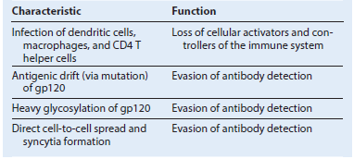

Epidemiology of Human Immunodeficiency Virus Infections
Disease Viral Factors
Enveloped virus is easily inactivated and must be transmitted in body fluids.
Disease has a long prodromal period.
Virus can be shed before development of identifiable symptoms.
Transmission
Virus is present in blood, semen, and vaginal secretions.
Who Is at Risk?
Intravenous drug abusers, sexually active people with many partners (MSM and heterosexual), prostitutes, newborns of HIV positive mothers, sexual partners of infected individuals.
Blood and organ transplant recipients and hemophiliacs treated before 1985 (before prescreening programs).
Geography/Season
There is an expanding epidemic worldwide.
There is no seasonal incidence.
Modes of Control
Antiviral drugs limit progression of disease.
Antiviral drugs for pre- and post-exposure prophylaxis.
No vaccines available.
Safe, monogamous sex helps limit spread.
Sterile injection needles should be used.
Circumcision.
Large-scale screening programs of blood for transfusions, organs for transplants, and clotting factors used by hemophiliacs.
MSM, Men who have sex with men.

Transmission of Human Immunodeficiency Virus Infection
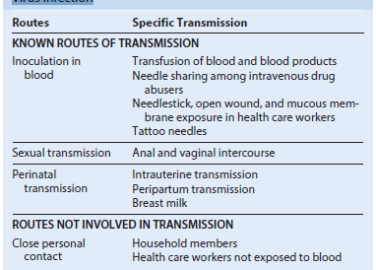

Indicator Diseases of Acquired Immunodeficiency Syndrome a
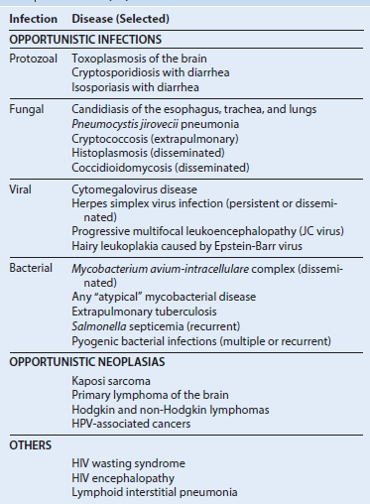
a Manifestations of HIV infection—defining AIDS according to criteria of Centers for Disease Control and Prevention. Modified from Belshe, R.B., Textbook of Human Virology, second ed. Mosby, St Louis, MO. HPV, Human papillomavirus.

Clinical Summary
A 32-year-old former heroin addict had a mononucleosis-like illness for 2 weeks. He recalled experiencing occasional night sweats and fever for 3 years and then presented with thrush, cytomegalovirus retinitis, and Pneumocystis pneumonia. His CD4 T-cell count was 50/μL. He was started on highly active antiretroviral therapy.
Laboratory Analysis for Human Immunodeficiency Virus
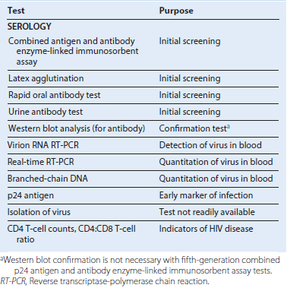

Potential Antiviral Therapies for Human Immunodeficiency Virus Infection
Nucleoside Analog Reverse Transcriptase Inhibitors
Azidothymidine (AZT) (Zidovudine) [Retrovir]
3TC (Lamivudine) [Epivir]
Tenofovir disoproxil fumarate (adenosine class) [Viread]
ABC (Abacavir) [Ziagen]
FTC (Emtricitabine) [Emtriva]
Nonnucleoside Reverse Transcriptase Inhibitors
Nevirapine [Viramune]
Doravirine [Pifeltro]
Efavirenz [Sustiva]
Etravirine [Intelence]
Rilpivirine [Edurant]
Protease Inhibitors (PIs)
Tipranavir [Aptivus]
Darunavir [Prezista]
Ritonavir [Norvir]
Fosamprenavir [Lexiva]
Atazanavir [Reyataz]
Saquinavir [Invirase]
Binding and Fusion Inhibitors
CCR5 inhibitor (maraviroc) [Selzentry]
Fusion inhibitor (enfuvirtide) [Fuzeon]
Integrase Inhibitor
Raltegravir [Isentress]
Dolutegravir [Tivicay]
Examples of Highly Active Antiretroviral Therapy
Efavirenz/tenofovir/emtricitabine (EFV/TDF/FTC) [Atripla]
Abacavir/zidovudine/lamivudine [Trizivir]
Dolutegravir/abacavir/lamivudine [Triumeq]
Emtricitabine, rilpivirine, and tenofovir disoproxil fumarate [Complera]
Elvitegravir/cobicistat/tenofovir/emtricitabine [Stribild]
Emtricitabine/tenofovir disoproxil fumarate [Truvada]
Lamivudine/zidovudine [Combivir]
Lopinavir/ritonavir [Kaletra]

Mechanisms of Retrovirus Oncogenesis
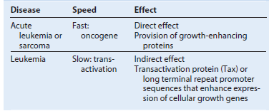
Representative Examples of Oncogenes
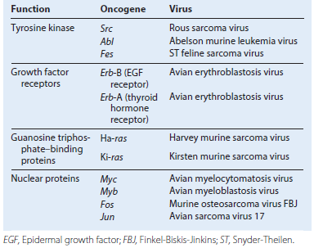

Oncogenic Viruses
Some DNA viruses and retroviruses establish persistent infections that can also stimulate uncontrolled cell growth, causing transformation or immortalization of the cell.
Characteristics of transformed cells include continued growth without senescence, alterations in cell morphology and metabolism, increased cell growth rate and sugar transport, loss of cell-contact inhibition of growth, and ability to grow in a suspension or pile up into foci when grown in a semisolid agar.
Different oncogenic viruses have different mechanisms for immortalizing cells. Viruses immortalize cells by (1) activating or providing growth-stimulating genes, (2) removing the inherent braking mechanisms that limit DNA synthesis and cell growth, (3) preventing apoptosis, or (4) providing or inducing growth-stimulating cytokines. Immortalization by DNA viruses occurs in semipermissive cells, which express only selected viral genes but do not produce virus. Synthesis of viral DNA, late mRNA, late proteins, or virus leads to cell death, which precludes immortalization. Several oncogenic DNA viruses integrate into the host cell chromosome. Papillomavirus, SV40 virus, and adenovirus encode proteins that bind and inactivate cell growth–regulatory proteins, such as p53 and the retinoblastoma gene product, releasing the brakes on cell growth. Loss of p53 also makes the cell more susceptible to mutation.
Epstein-Barr virus immortalizes B cells by stimulating cell growth (as a B-cell mitogen) and by preventing programmed cell death (apoptosis).
Retroviruses (RNA viruses) use three approaches to oncogenesis. Some oncoviruses encode oncogene proteins (e.g., SIS, RAS, SRC, MOS, MYC, JUN, FOS) that are almost identical to the cellular proteins involved in cellular growth control (e.g., components of a growth-factor signal cascade [receptors, G-proteins, protein kinases], or growth-regulating transcription factors). The overproduction or altered function of these oncogene products stimulates cell growth. These oncogenic viruses rapidly cause tumors to form. However, no human retrovirus of this type has been identified.
Human T-cell lymphotropic virus 1 (HTLV-1), the only human oncogenic retrovirus identified, uses more subtle mechanisms of leukemogenesis. It encodes a protein (TAX) that transactivates gene expression, including genes for growth-stimulating cytokines (e.g., interleukin [IL]-2). This constitutes two approaches for oncogenesis.
The third approach is integration of the DNA copy of HTLV-1 near a cellular growth-stimulating gene, which can also cause the gene to be activated by the strong viral enhancer and promoter sequences encoded at each end of the viral genome (long terminal repeat [LTR] sequences). HTLV-1–associated leukemias develop slowly, occurring 20 to 30 years after infection. Retroviruses continue to produce the virus in immortalized or transformed cells. Some viruses may initiate tumor formation indirectly.
Hepatitis B virus (HBV) and HCV may have mechanisms for direct oncogenesis; however, both viruses establish persistent infections that cause inflammation and require significant tissue repair. Inflammation and continuous stimulation of liver cell growth and repair may promote mutations that lead to tumor formation. Human herpesvirus-8 (HHV-8) promotes the development of Kaposi sarcoma by means of growth-promoting cytokines encoded by the virus; this disease occurs most often in immunosuppressed patients, such as those with AIDS.
Viral transformation is the first step but is generally not sufficient to cause oncogenesis and tumor formation. Instead, over time, immortalized cells are more likely than normal cells to accumulate other mutations or chromosomal rearrangements that promote development of tumor cells. Immortalized cells may also be more susceptible to cofactors and tumor promoters (e.g., phorbol esters, butyrate) that enhance tumor formation. Approximately 15% of human cancers can be related to oncogenic viruses such as HTLV-1, HBV, HCV, human highrisk papillomaviruses, HHV-8, and Epstein-Barr virus.
Chronic and Potentially Oncogenic Infections
Chronic infections occur when the immune system has difficulty resolving the infection. The DNA viruses (except parvovirus and poxvirus) and the retroviruses cause latent infections with the potential for recurrence. CMV and other herpesviruses; hepatitis viruses B, C, G, and D; and retroviruses cause chronic productive infections. These “passengers” may influence the health of the individual in subtle ways.
HBV, HCV, EBV, HHV-8, HPV, and HTLV-1 are associated with human cancers. EBV, HPV, and HTLV-1 can immortalize cells; after immortalization, cofactors, chromosomal aberrations, or both enable a clone of virus-containing cells to grow into a cancer. EBV normally causes infectious mononucleosis but is also associated with African Burkitt lymphoma, Hodgkin lymphoma, lymphomas in immunosuppressed individuals, and nasopharyngeal carcinoma; HTLV-1 is associated with human adult T-cell leukemia. Many papillomaviruses induce a simple hyperplasia characterized by the development of a wart; however, several other strains of HPV have been associated with human cancers (e.g., types 16, 18, 33, 35, 58, and 68 are associated with cervical, anal, penile and oropharyngeal cancers.).
Direct viral action or the inflammation and chronic cell damage and repair in livers infected by HBV or HCV can result in a tumorigenic event leading to hepatocellular carcinoma. Immunosuppression in patients who have AIDS, patients undergoing cancer chemotherapy, or transplant recipients also allows the production of lymphoma by EBV. HHV-8 infection produces many cytokines to stimulate cell growth, and this growth can progress to Kaposi sarcoma, especially in persons with AIDS.
Vaccines are now available for HBV and high-risk HPV strains. Vaccination has reduced the spread of viral hepatitis, which will reduce the occurrence of primary hepatocellular carcinoma. Similarly, the HPV vaccines should also reduce the incidence of cervical and other HPV associated cancers.
PRIONS
Trigger Words
Creutzfeldt-Jakob disease, spongiform encephalopathy, kuru, presenile dementia, myoclonus
Biology, Virulence, and Disease
ᑏ Prions are infectious protein aggregates resistant to inactivation
ᑏᑏ Prions consist of assembled subunits with an alternate conformation of normal host proteins (PrP)
ᑏᑏNormal PrP protein binds to the PrPSc or the multimeric PrPSc, which alters its conformation and binds and extends fibrils
ᑏᑏCollect in brain, where they cause spongiform vacuoles
ᑏᑏNo immune response, no inflammation
ᑏᑏAcquired, genetic, and sporadic forms of prion disease
ᑏᑏCreutzfeldt-Jakob disease (presenile dementia), kuru, Gerstmann-Sträussler-Scheinker disease, fatal familial insomnia
Epidemiology
ᑏᑏ Transmitted on contaminated surgical devices, by injection, in food, or genetic
Diagnosis
ᑏᑏ Symptomatology, MRI, indirect assays
Treatment, Prevention, and Control
ᑏᑏ Rigorous disinfection procedures
ᑏᑏNo means of prevention or control
MRI, Magnetic resonance imaging.

Comparison of Classic Viruses and Prions
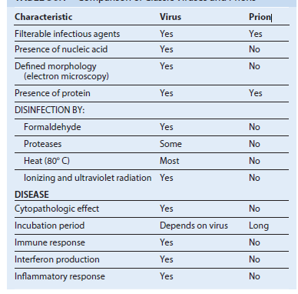

Prion Diseases
Human
Kuru
Creutzfeldt-Jakob disease
Variant CJD
Gerstmann-Sträussler-Scheinker syndrome
Fatal familial insomnia
Sporadic fatal insomnia
Animal
Scrapie (sheep and goats)
Transmissible mink encephalopathy
Bovine spongiform encephalopathy (BSE [mad cow
Comparison of Scrapie Prion Protein and (Normal) Cellular Prion Protein
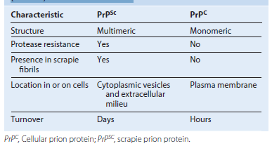

Pathogenic Characteristics of Prions
No cytopathologic effect in vitro
Long doubling time of at least 5.2 days
Long incubation period
Cause vacuolation of neurons (spongiform), amyloid-like plaques, gliosis
Cause loss of muscle control, shivering, tremors, dementia
Lack of antigenicity
Lack of inflammation
Lack of immune response
Lack of interferon production
Epidemiology of Disease Caused by Prions
Disease/Viral Factors
Agents are impervious to standard microbial disinfection procedures.
Diseases have very long incubation periods, as long as 30 years.
Disease acquisition may be infectious, genetic, or sporadic (random occurrence).
Transmission - Transmission is via infected tissue, or syndrome may be inherited.
Infection can occur by ingestion,through cuts in skin, transplantation of contaminated tissues (e.g., cornea), and use of contaminated medical devices (e.g., brain electrodes).
Who Is at Risk? - Members (especially women and children) of the Fore tribe in New Guinea were at risk for kuru because of ritual cannibalism. Surgeons, transplant and brain-surgery patients, and others are at risk for CJD and GSS syndrome.
Geography/Season - GSS syndrome and CJD have sporadic occurrence worldwide.
There is no seasonal incidence.
Modes of Control - No treatments are available.
Cessation of ritual cannibalism has led to the disappearance of kuru.
Elimination of animal products from livestock feed to prevent vCJD development and transmission, For GSS syndrome and CJD, neurosurgical tools and electrodes should be disinfected in 5% hypochlorite solution or 1.0 M sodium hydroxide or autoclaved at 15 psi for 1 hour.
CJD, Creutzfeldt-Jakob disease; GSS, Gerstmann-Sträussler-Scheinker; vCJD, variant Creutzfeldt-Jakob disease.
Template-mediated protein refolding model for proliferation of prions. PrPC is a normal cellular protein that is anchored in the cell membrane by phosphatidylinositol glycan. PrPSc is a hydrophobic globular protein that aggregates with itself and with PrPC on the cell surface (1). PrPC acquires the conformation of PrPSc (2). The cell synthesizes new PrPC (3), and a chain is built along cell surface anionic glycosaminoglycans (4). The chain breaks on phagocytosis or from shear forces and releases PrPSc aggregates that act like seed crystals to start the cycle over. A form of PrPSc is internalized by neuronal cells and accumulates (5). Other models have been proposed.
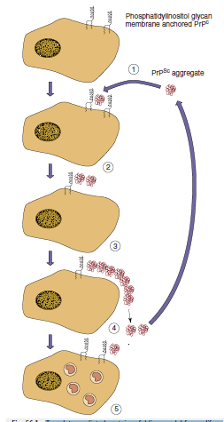

Progression of transmissible Creutzfeldt-Jakob disease.
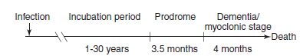
Creutzfeldt-Jakob disease: A 63-year-old man complained of poor memory and difficulty with vision and muscle coordination. Over the course of the next year, he developed senile dementia and irregular jerking movements, progressively lost muscle function, and then died.
Variant Creutzfeldt-Jakob disease: A 25-year-old is seen by a psychiatrist for anxiety and depression. After 2 months, he has problems with balance and muscle control and has difficulty remembering. He develops myoclonus and dies within 12 months of onset.

